I

**USER MANUAL**

**IBM SKILLS BUILD**

Last updated : 27/03/2024

Group 01

Kevin Han - jh892

Mikail Arioz - ma1002

Jahnavi Muniraj - jm958

Leandro De Noronha - ldn5

Enzo Brown - eb433

Miracle Ndu - mn303

Yash Parmar - yp114

Ben Millington - bm308

Purpose : This document was built to help a user understand the content inside IBM Skills Build. IBM Skills Build is designed to help develop valuable skills and career readiness. The platform tracks the progress and offers guidance so users can effectively develop skills that match their career goals.

Contents

Register Page 2

Login Page 5

Dashboard Feature 7

Streaks Feature 8

Record start times 9

Leaderboard Feature 11

Progress Bar Feature 12

Quiz Feature 15

Comment and rating on course 16

Avatar Feature 19

Friends Feature 22

Admin Analytics Feature 24

# Register Page

**Introduction**

1. Welcome to the user manual for the Register Page. This document will guide you through the process of accessing the Register Page and registering a new account.

**Accessing the Register Page**

1. To access the Register Page, follow these steps:
2. Open your web browser (e.g., Google Chrome, Mozilla Firefox, Safari).

1. In the address bar, enter the URL of the website (<http://localhost:8080>) where the Login Page is located. Then click on “Don’t Have An Account?”

**Registering**

Once you've accessed the Register Page, you'll need to register a new account. Follow these steps to register:

1. Enter your desired username and password in the “User Name” and “Password” field respectively.

1. After clicking “SIGN UP” you will be redirected to the login page where you will have to enter the credentials you have just created then you will have an access to the dashboard.

By Mikail

# Login Page

**Introduction**

Welcome to the user manual for the Login Page. This document will guide you through the process of accessing the Login Page and logging in to your account.

**Accessing the Login Page**

To access the Login Page, follow these steps:

1. Open your web browser (e.g., Google Chrome, Mozilla Firefox, Safari).

1. In the address bar, enter the URL of the website (<http://localhost:8080>) where the Login Page is located.



1. Press Enter or Return on your keyboard to navigate to the website.

Once you've accessed the Login Page, you'll need to log in to your account. Follow these steps to log in:

1. Enter your username in the "User Name" field.

1. Enter your password in the "Password" field.

1. Click or tap the "Sign In" button to submit your login credentials.

By Yash

# Dashboard Feature

**Introduction**

The dashboard allows you to view key metrics and data visualisations to monitor the status and performance of the system . This user manual provides instructions on how to access and navigate the dashboard. 

1.After logging in the with login credentials, the user will be redirected to the dashboard.

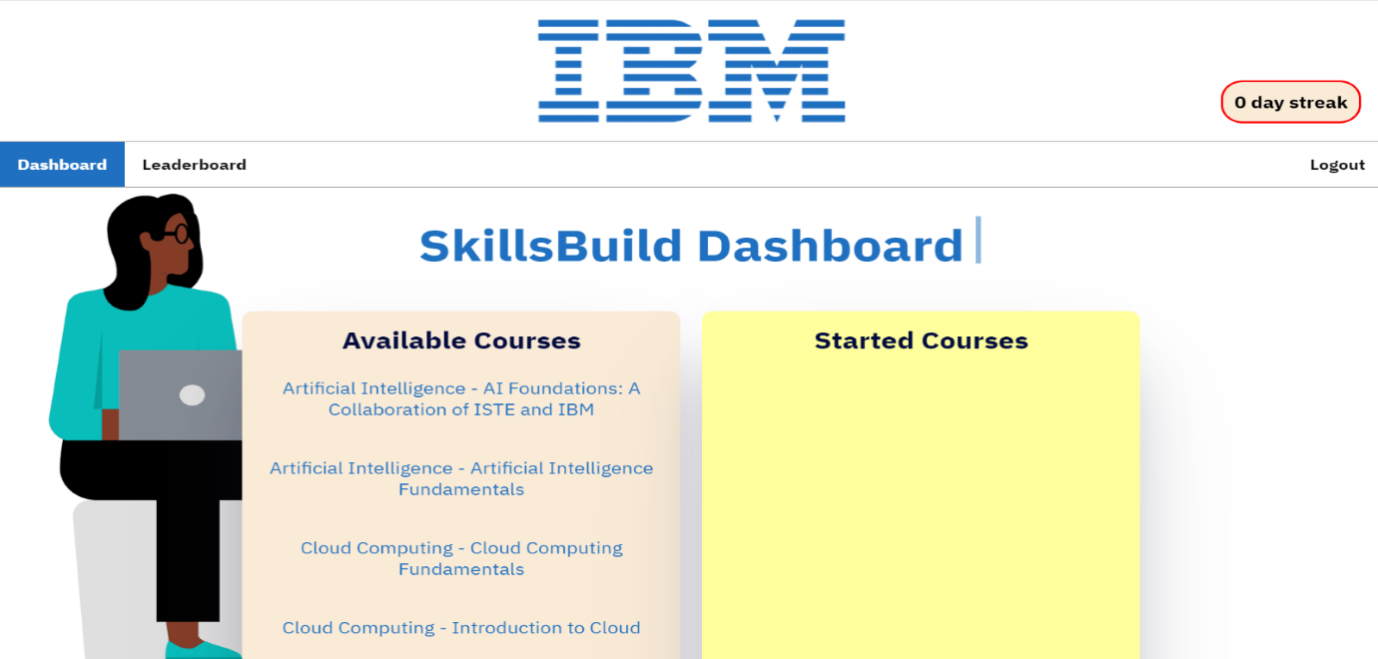

1. The dashboard has 2 buttons, leaderboard and logout. The user can access the leaderboard and can see the streaks as well.
2. If the user clicks on the courses, it expands and brings up a description, with a button to enrol/complete the course.

By Jahnavi and Ben

# Streaks Feature

The streaks feature tracks the consecutive days a user logs into the system and updates their streak count accordingly.

1. To see the streaks the user must have logged in using their credentials and their streak will be displayed on the dashboard.

1. The key components of the streak include:

* It adds on when you log in for a consecutive day
* It resets when you fail to log on for a day
* It makes sure not to add on if you log in multiple times in a day.

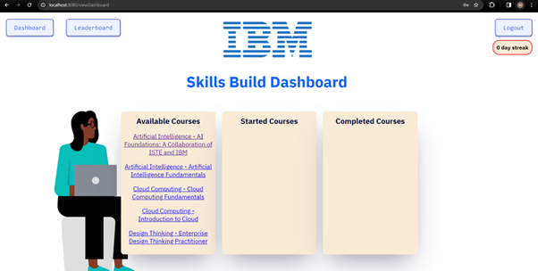

By Miracle

# Record start times

**Introduction**

This is the user manual for recording start times. Following the user story, “As a Student, I want the app to record when I begin an IBM SkillsBuild Course so that I can pause and resume the courses”, the code contains all the features required.

**How to find the pause and resume course function**

1. Open the web browser (Google Chrome, Firefox, Bing, etc.)

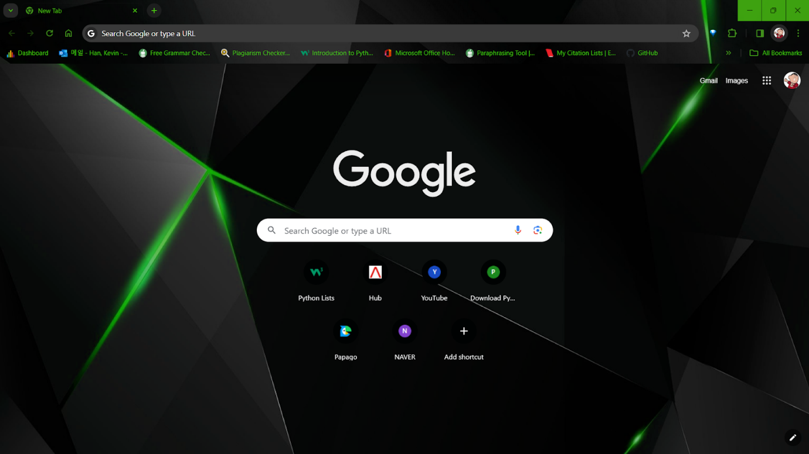

1. In the search bar, type “localhost:8080/record-start” which will lead the user to the course time control page.



**How to control the course time**

1. When you type the above URL to the search bar this webpage will be shown, and current time is shown in unit seconds.

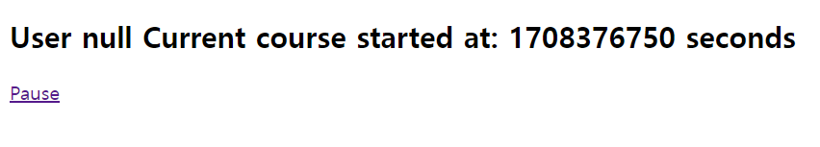

1. If you are willing to stop the course now, you can click the pause button to stop recording the time (time will be recorded throughout the activity until the stop button is pressed).



1. If you are willing to resume the course, you can simply click the resume button to resume recording the time.



By Kevin

# Leaderboard Feature

**Introduction**

Welcome to the user manual for the leaderboard feature. This manual will guide you on how to access the leaderboard.

1.First complete login manual to access dashboard. **(Instructions for in Login Manual)**

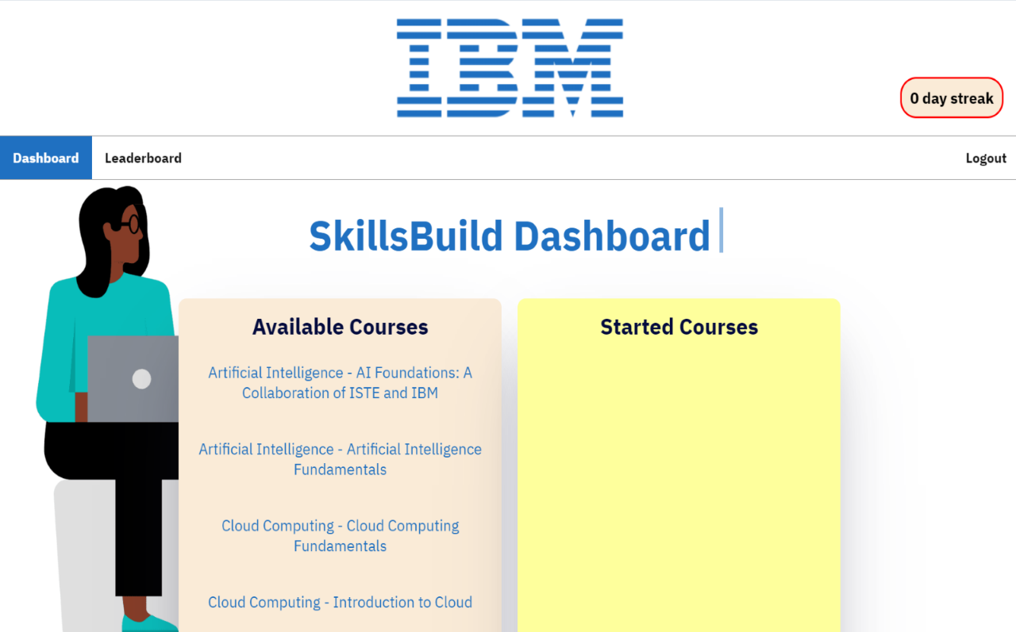

2. From the dashboard click leaderboard on the navigation bar

3.You will then be sent to the leaderboard page where you can view your global standing and then your standing with friends (if you have any on your account).

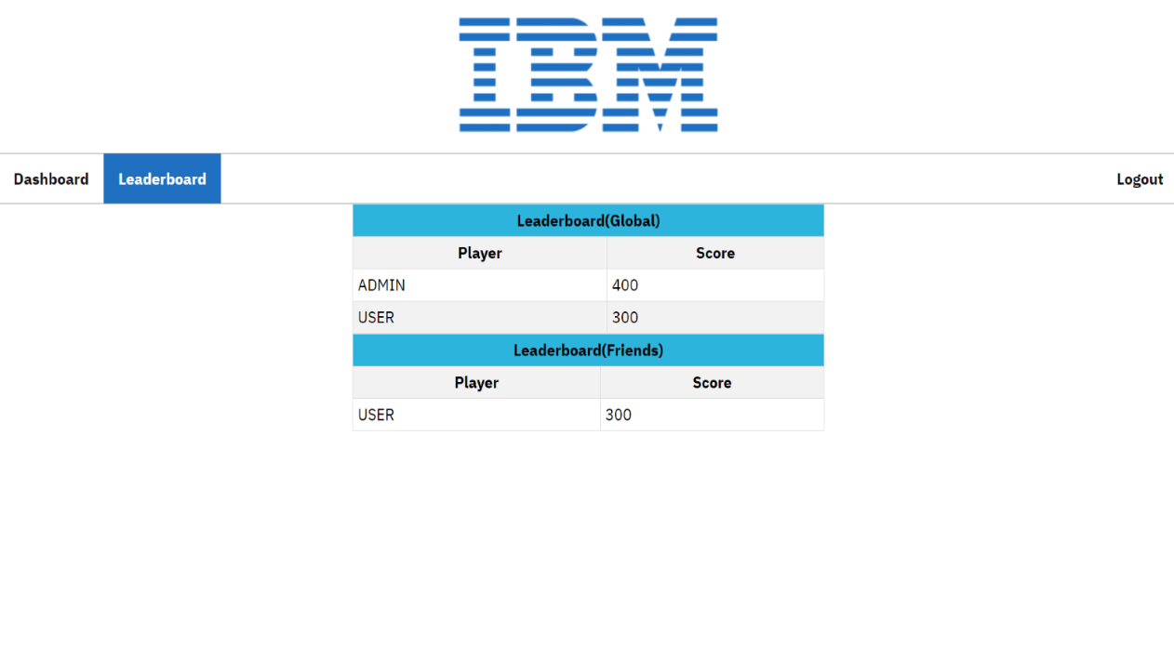

By Enzo

# Progress Bar Feature

1. Click on available courses and start a course.

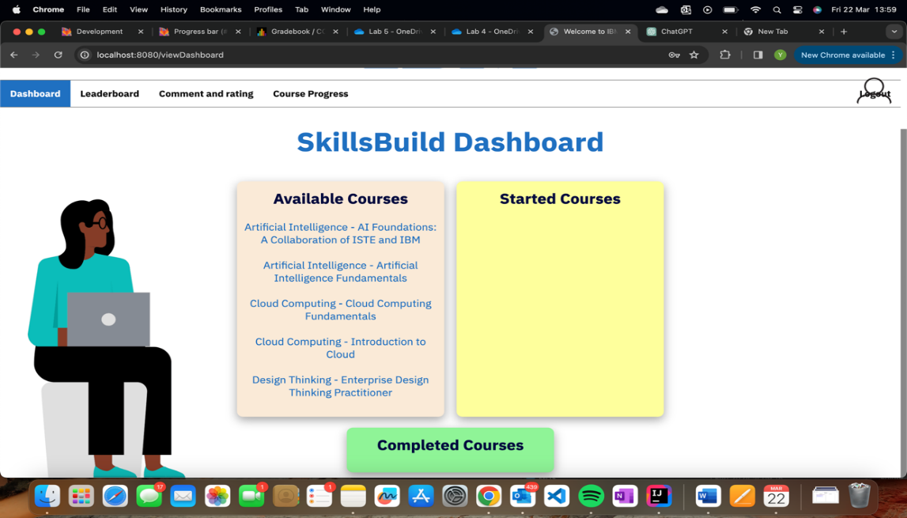

1. Once you have finished the course press the tick button to move it to completed courses.

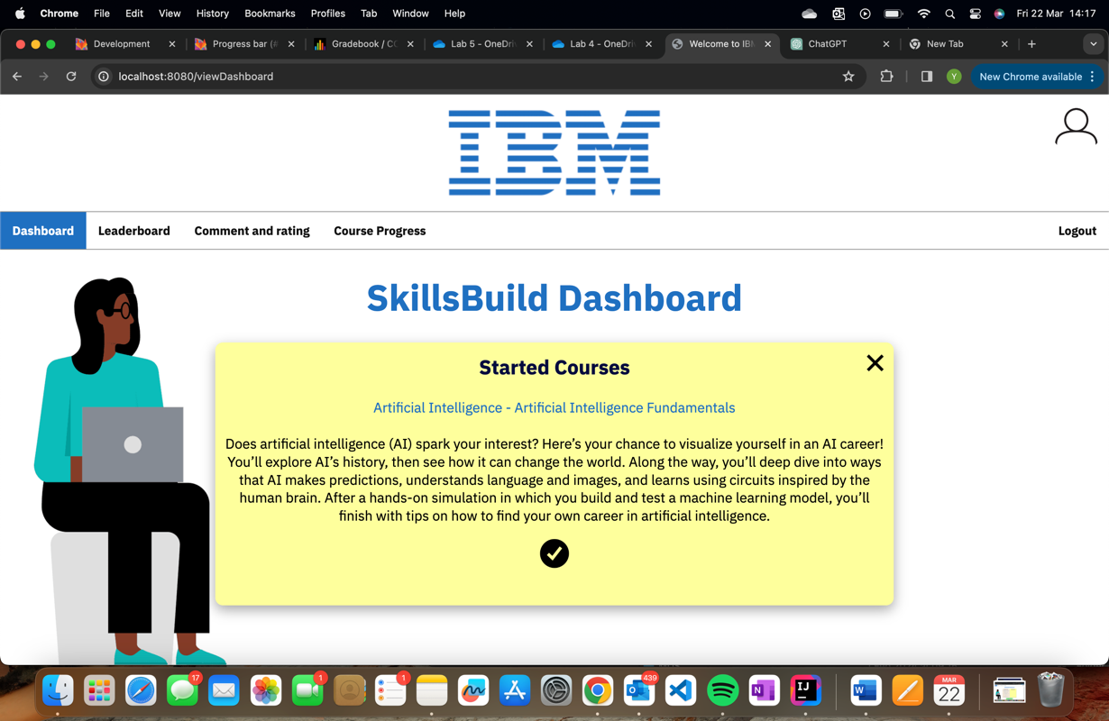

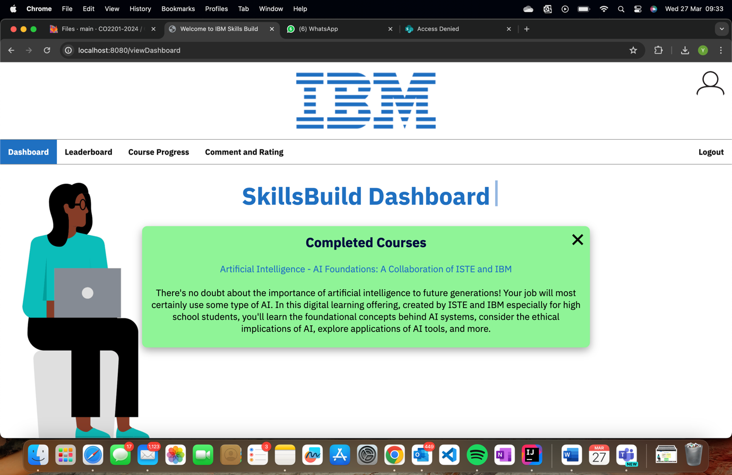

1. Now that the course is completed press Course Progress so you can view your courses and the progress you made on each course category.

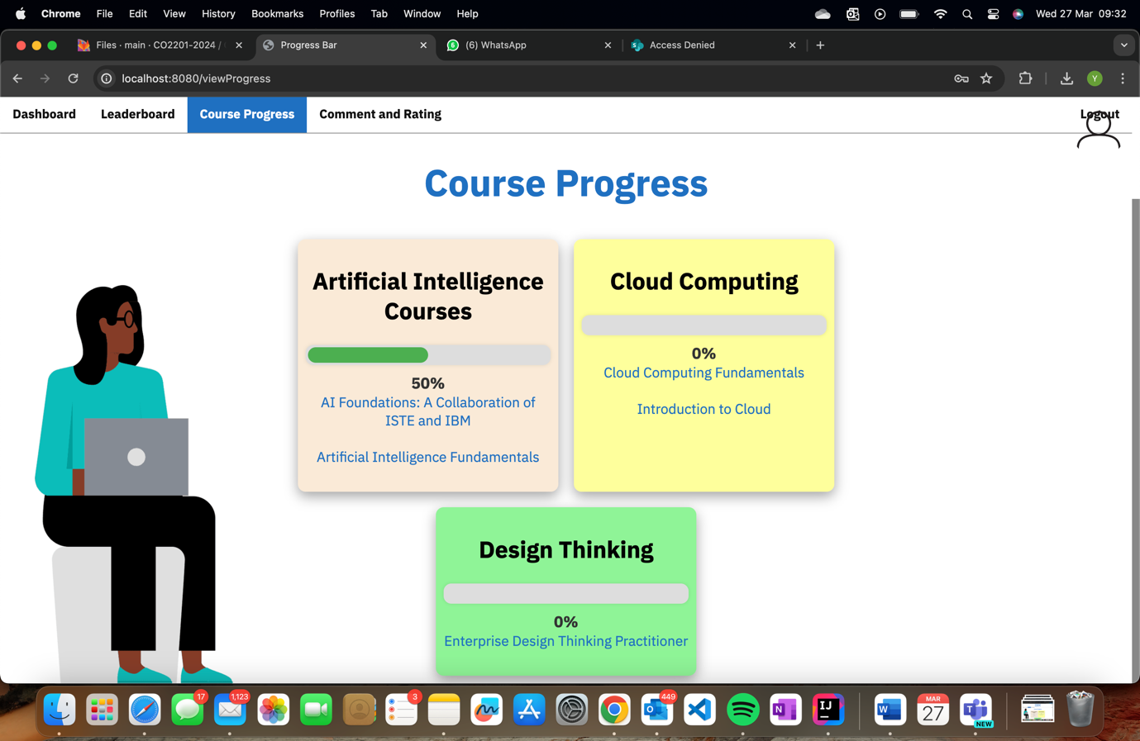 4.You can also view your progress straight after you’ve logged in by navigating to course progress   
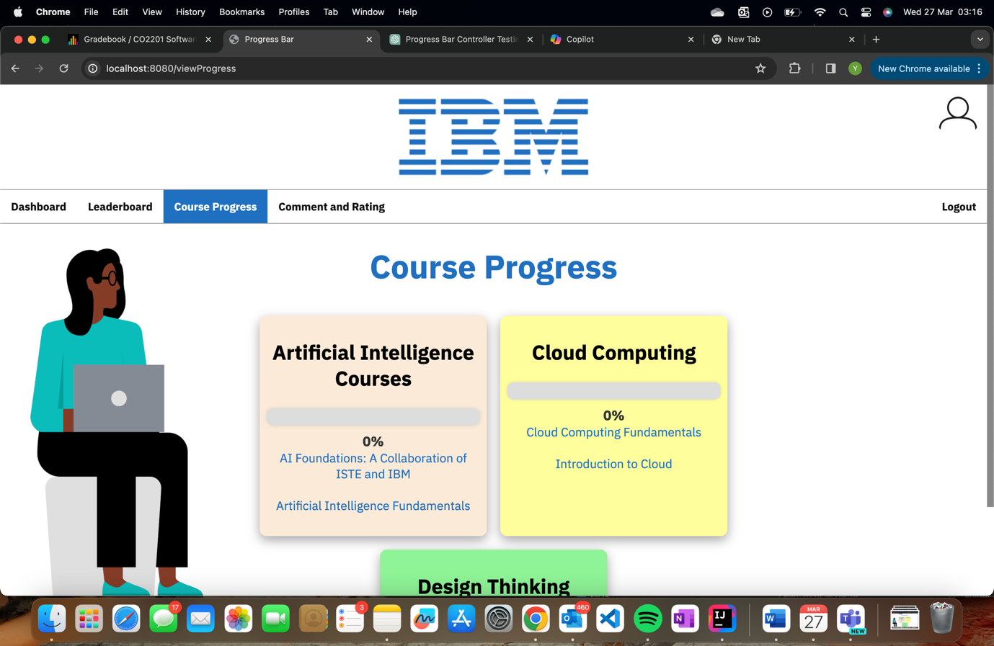

By Yash

# Quiz Feature

**Please go to locolhost:8080/quiz**

1.The user will be able to take the quiz after completing a course, the questions will be relevant to the course completed.

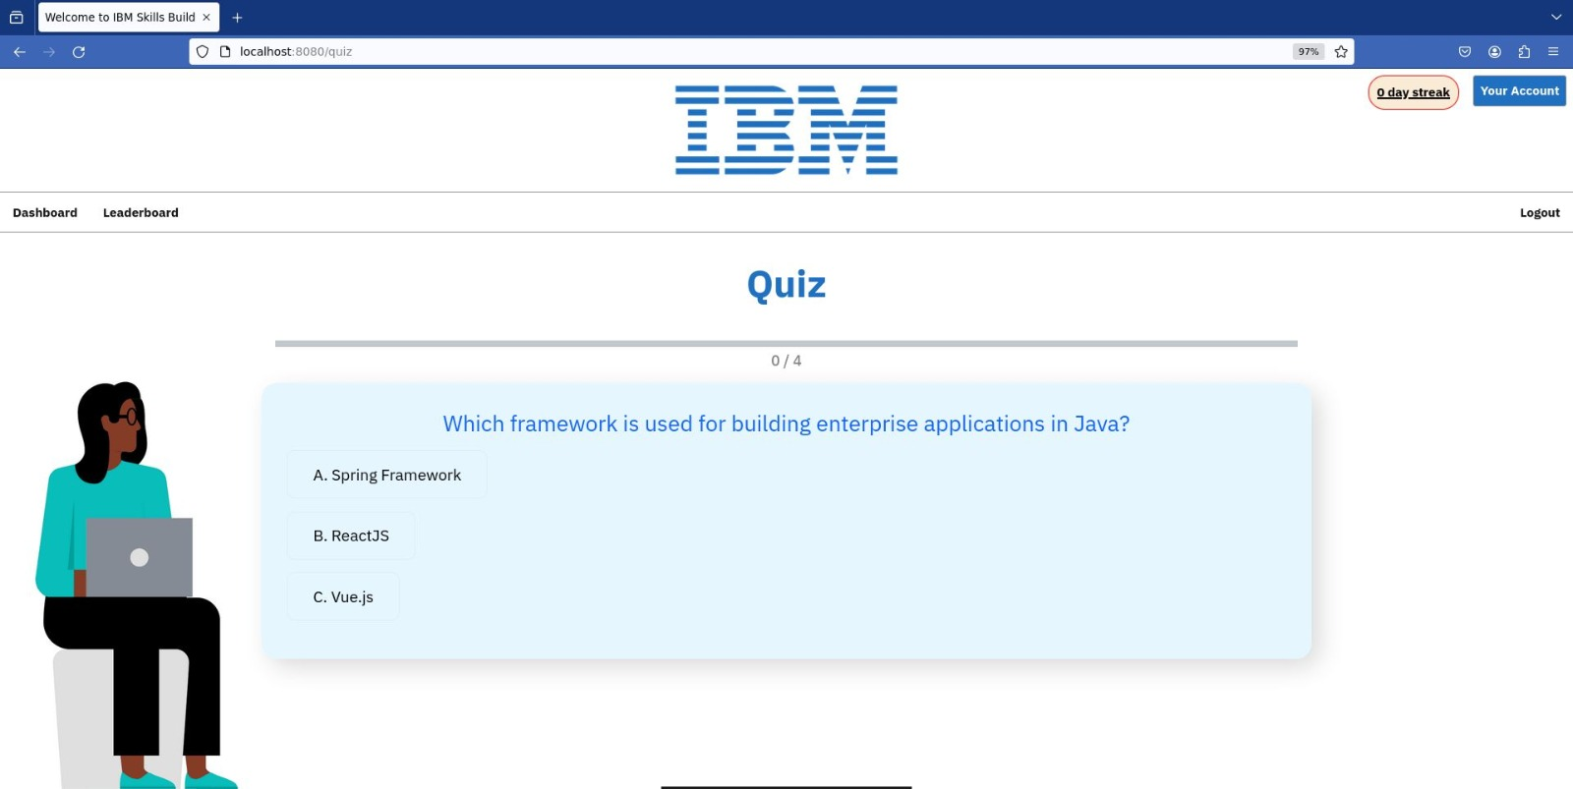

1. The user can see the progress halfway through the quiz.

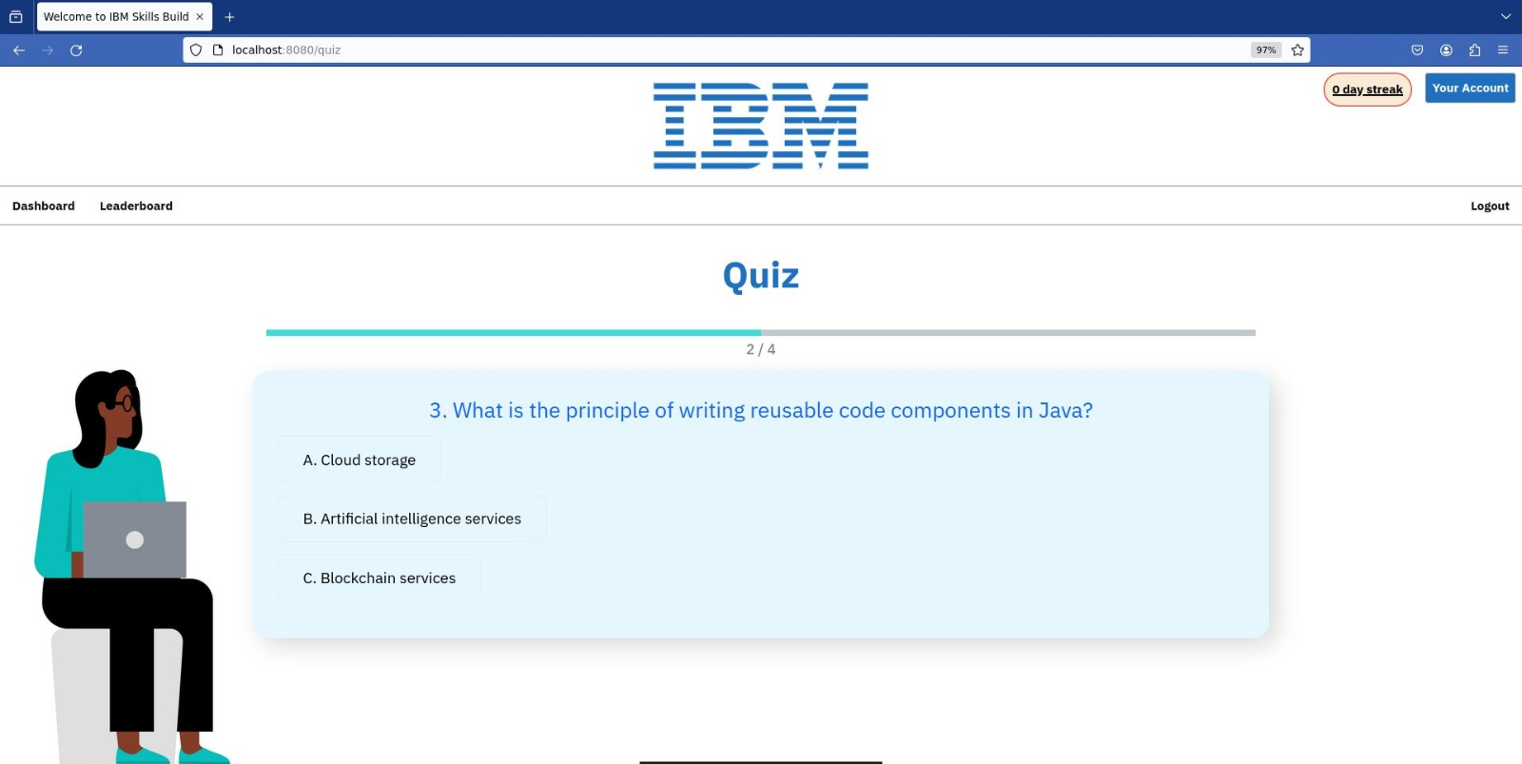

1. The score/results are displayed at the end of the quiz .



By Jahnavi

# Comment and rating on course

**Introduction**

This is the user manual for comment and rating on course. Following the user story, “As a student, I want to leave a comment and a rating on a course after I have completed it so that I can suggest improvements or encourage others to complete the course.”, the code contains all the features required.

**How to access the comment and rating section**

1. The user must have logged in using their credentials before accessing the comment and rating section.
2. The navigation bar will be visible beneath the IBM logo.

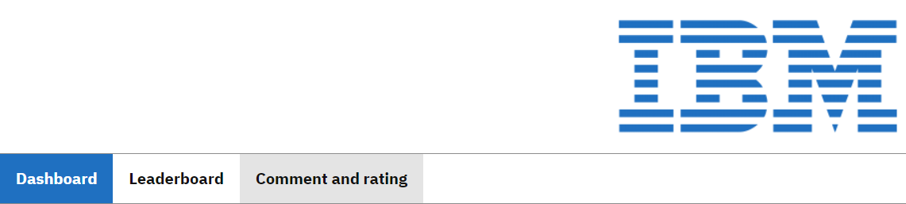

1. After clicking on the Comment and rating navigation button, fully functional comment and rating section will appear to the user’s screen.

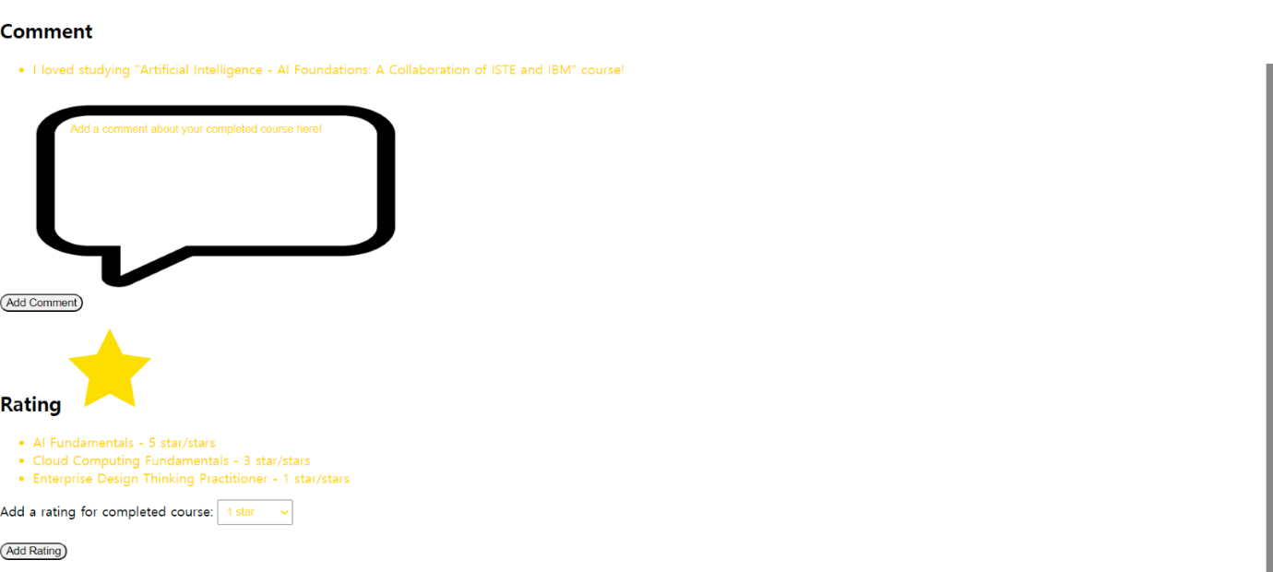

**Comment Section:**

* In the comment section, there will be an existing comment listed by other students who have completed the courses.



* As the user adds comment after typing inside the comment box, the commented text will be added below the existing comment.
* For example, “There should be more contents in “Cloud Computing Fundamentals” course.”

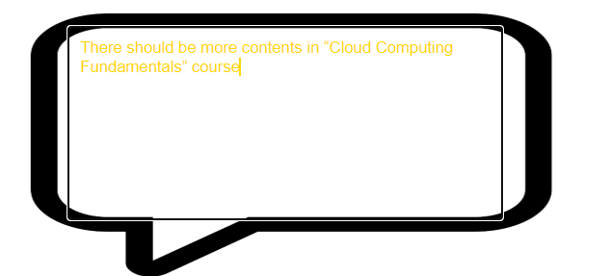



* If the user does not type in the comment box and then clicks on the “Add Comment” button, the system will display an alert message, “Please enter a comment.”

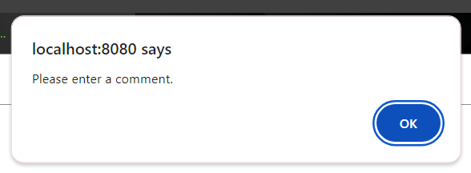

**Rating Section:**

* In the rating section, there will also be existing ratings listed by other students who have completed the courses.
* 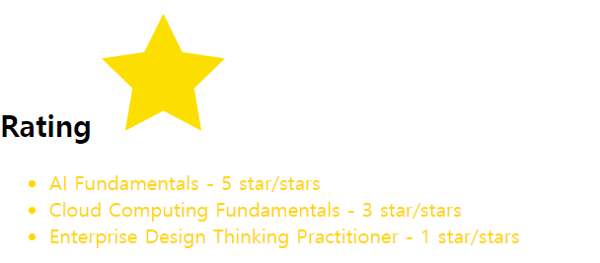
* The user can select different rating options (1~5 stars) from different courses when they click on the option list button.

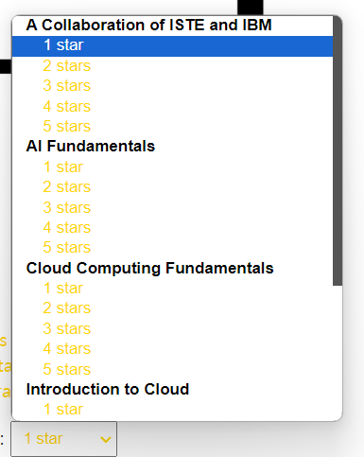

* Then if the user selects the rating for a specific course (e.g., Introduction to Cloud – 2 stars), the rating input will be added beneath to the existing rating list.

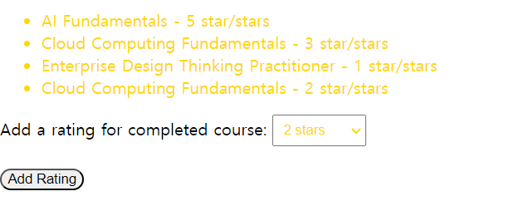  
By Kevin Han

# Avatar Feature

These are the instructions for how the avatar feature works and some of the things it can do.

1. When you first log on you will not have an avatar so the default image will be displayed on your profile page and nav bar. Once you’re ready you click edit avatar to create your avatar.

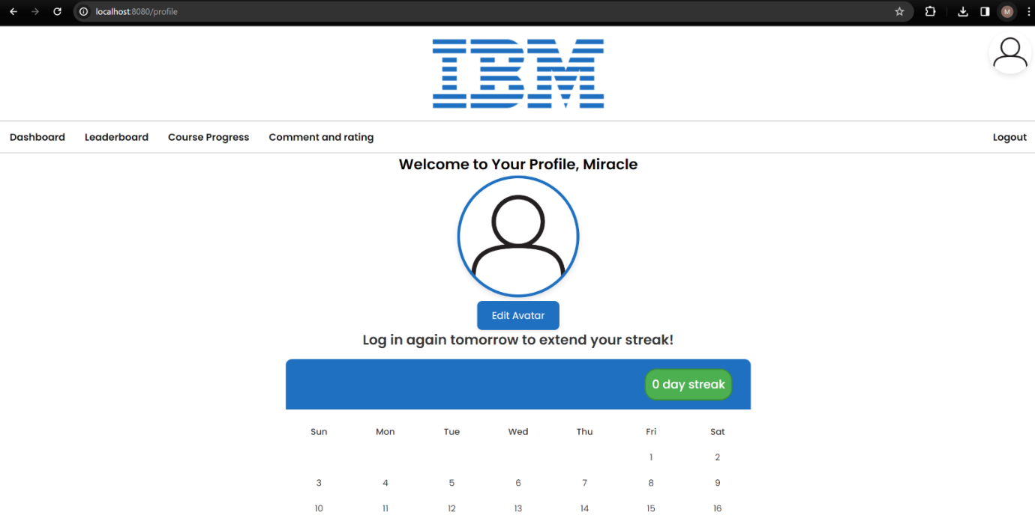

1. Once you have many options to customise how you would like and once you are ready to, you can save it.

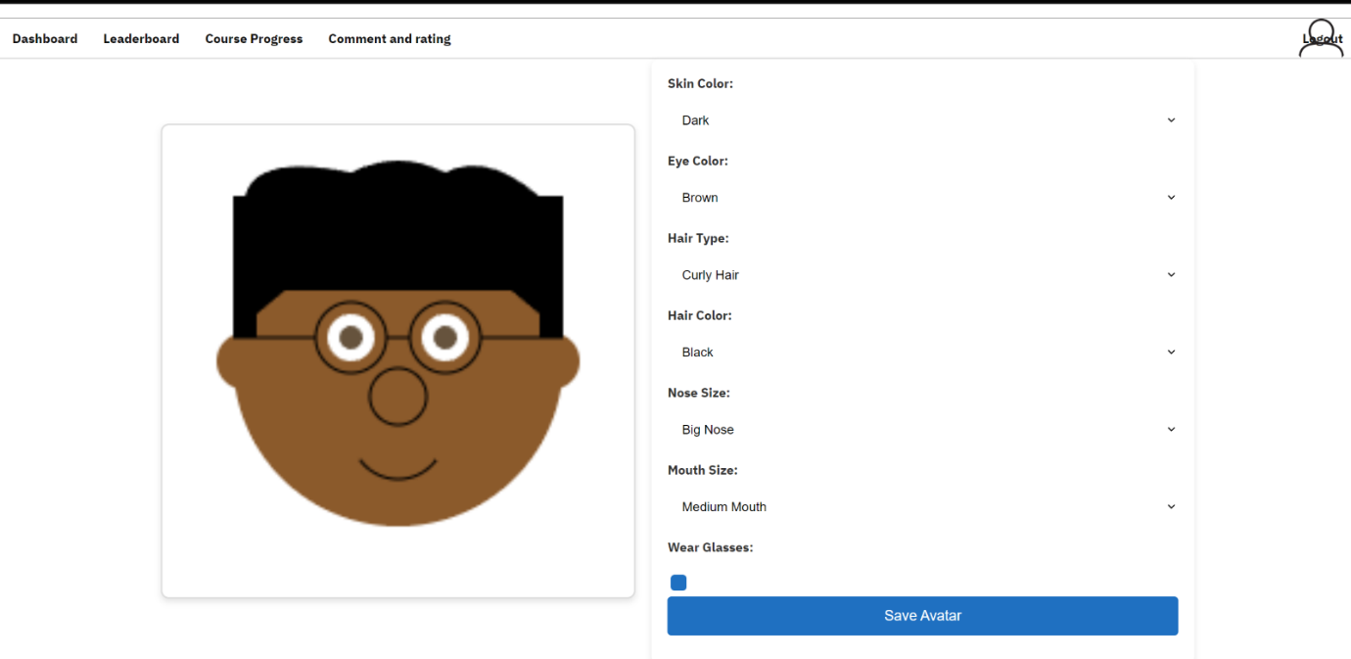

1. After making these changes you will be able to see your new avatar on the nav bar and on your profile page. You can also go back to edit avatar where you left of if you want to make any changes.

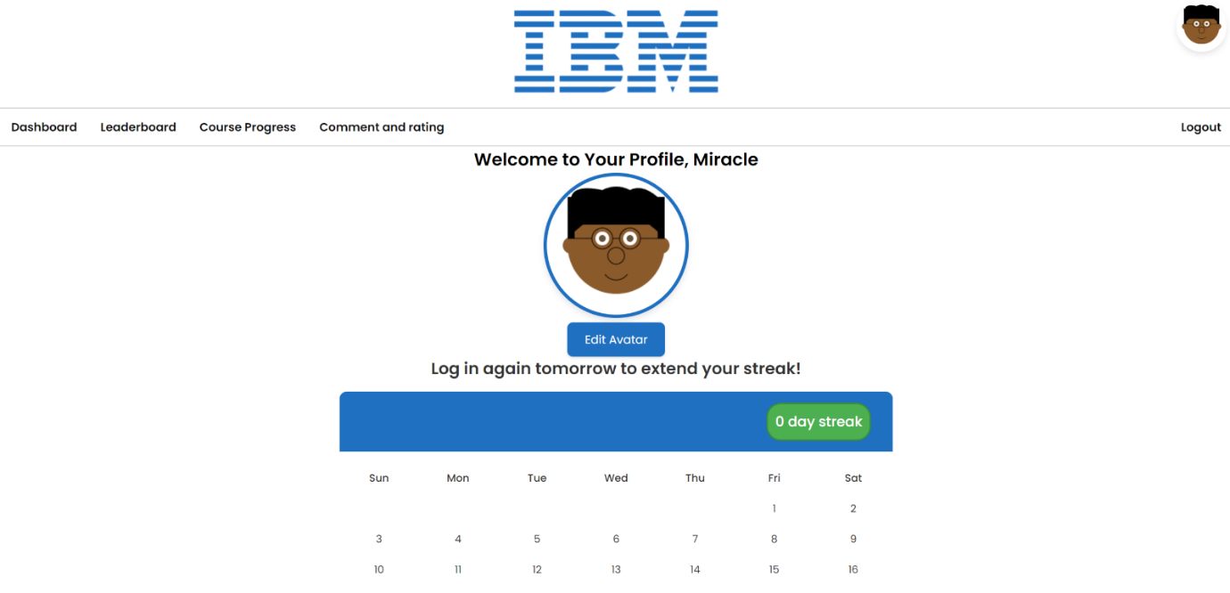

1. After creating your avatar, you can also see it on the global and friend's leaderboard and compare it to people around the world while learning.

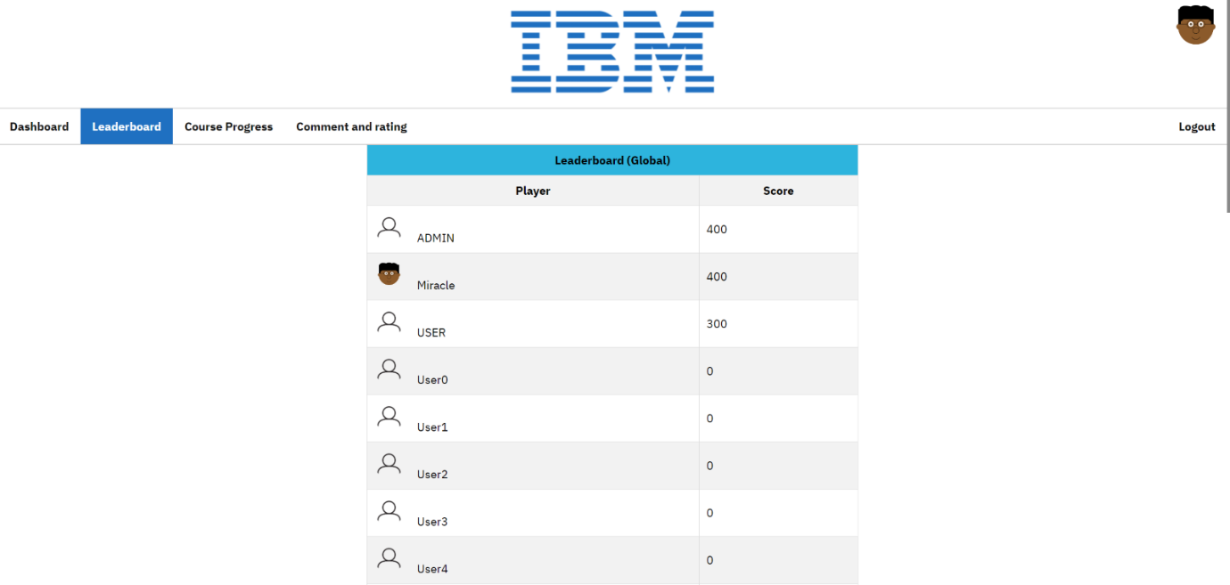

 By Miracle

# Friends Feature

**Introduction**

Welcome to the instructions on how to use the friend's feature. This manual will guide you on how to access the friend page, add friends, and remove friends.

1. First complete the login manual to access the dashboard page (Instructions **for Login Manual)**

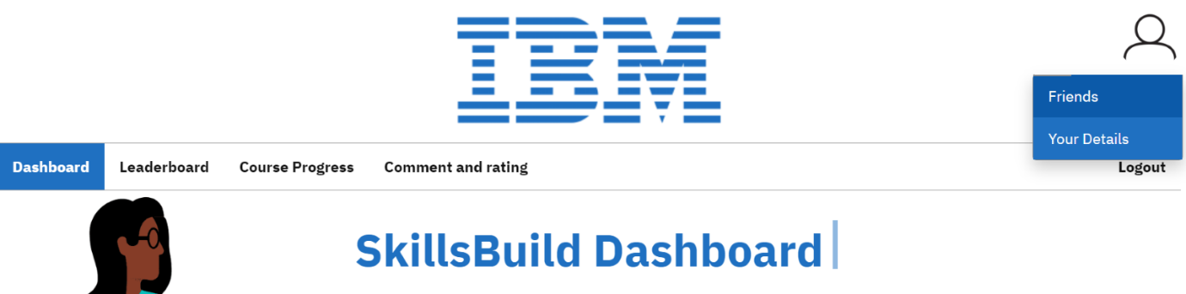

2. From the dashboard hover over the user icon in the top right corner and click “Friends” from the dropdown menu.

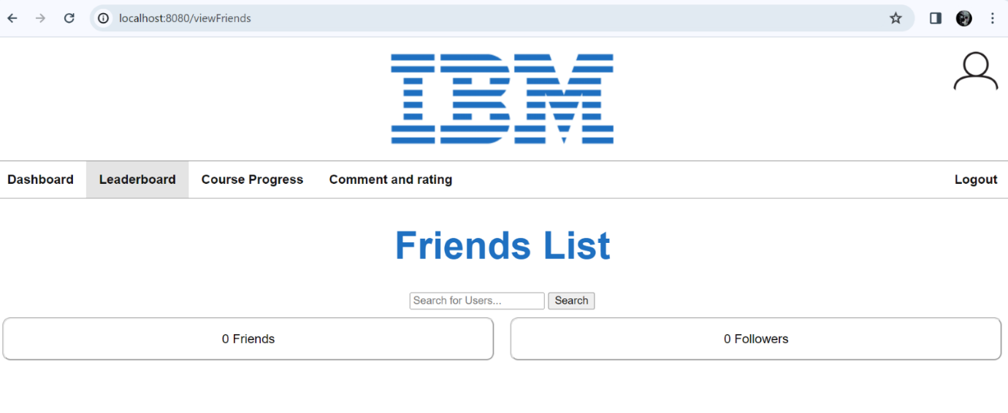

3. You will then be Taken to this page where you can view your “friends” and “followers” and also search for users to add to your Friends List. To add a friend, you first need to search for users.

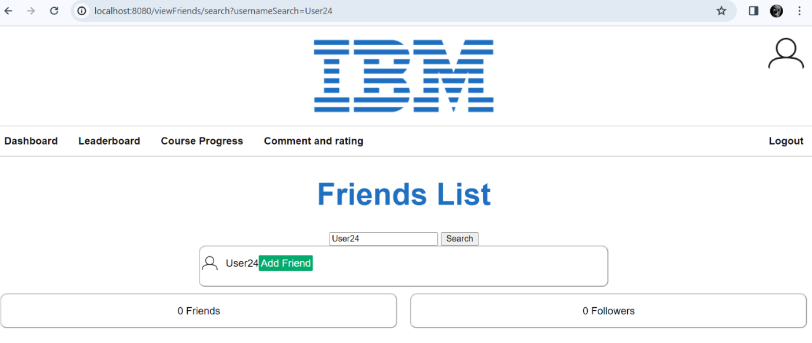

4.Once you have searched a user a list matching the searched username will appear with an “add Friend” button once you press this button they will be added to your “Friends” List.

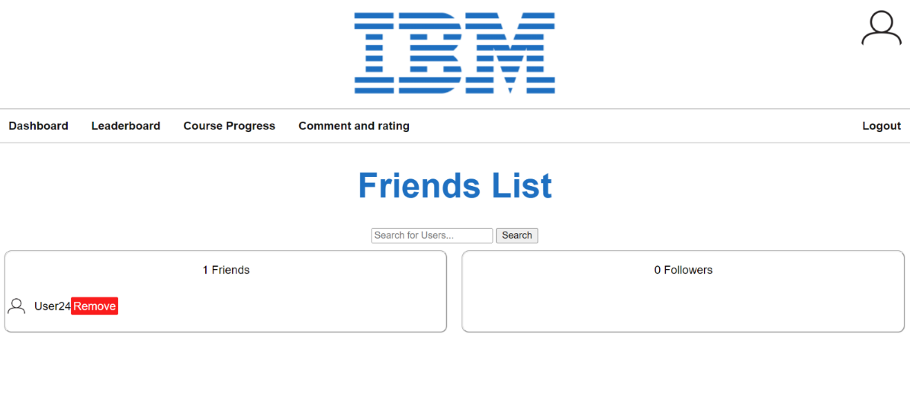

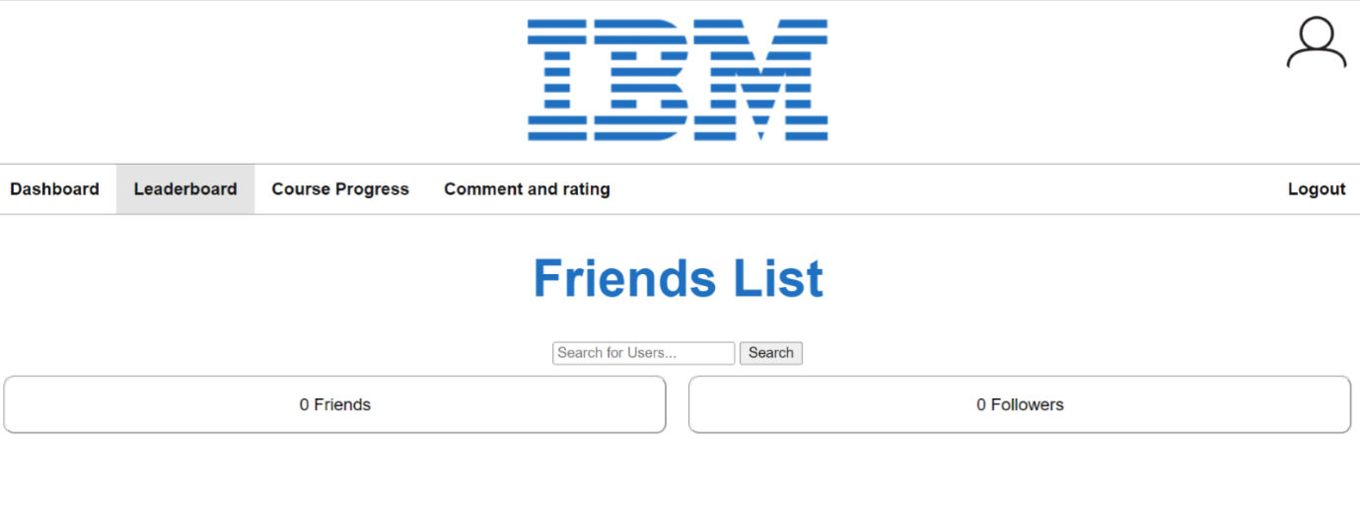

5.Once a user is added you will also have the option to remove them from your “friends” list by pressing the “remove” button.

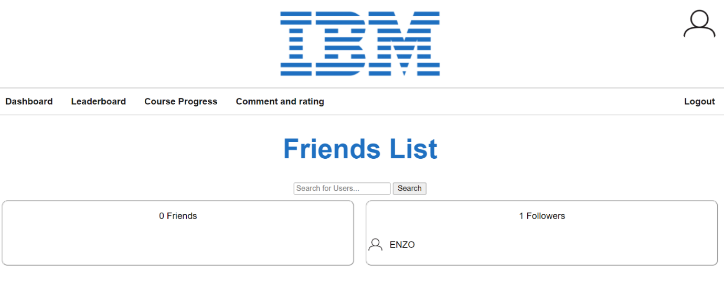

6. Once you add a user as a friend it will also notify them by adding you to their “followers” list.

By Enzo

# Admin Analytics Feature

1. First, log in to the system using admin credentials. Without admin credentials, you will not be able to access the analytics dashboard. After logging in, use the ‘Admin’ menu in the top left of the page to navigate to the ‘Analytics Dashboard’.

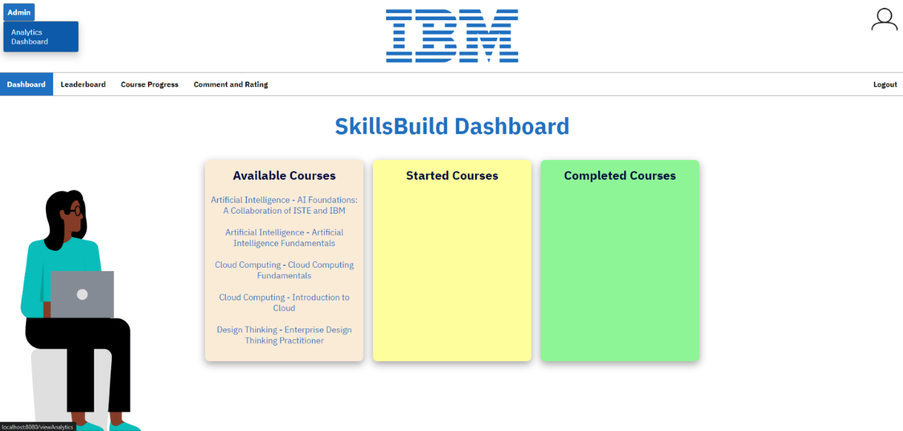

1. On the Analytics Dashboard, you can:
2. Interact with the graphs by mousing over the graphs, clicking on the legends to hide/show information, or clicking on the name of a specific course.

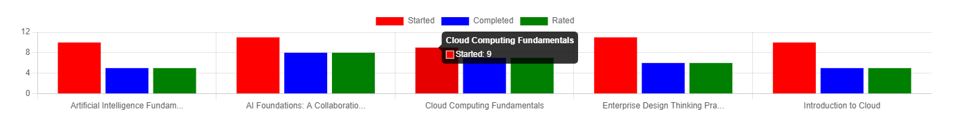

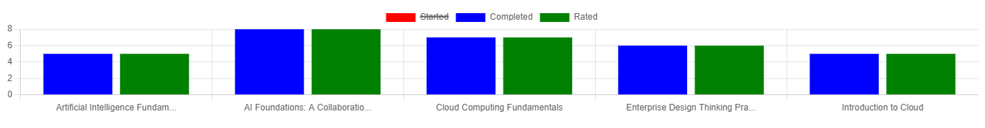

1. Search for a specific course by typing your search query into the search bar and selecting the desired course from the pop-up menu.

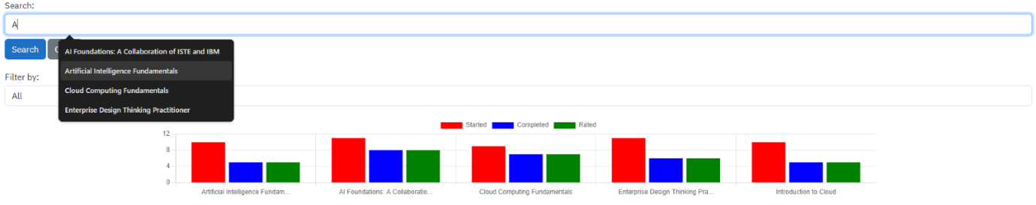

Clicking the clear button will remove your search query from the search bar.

1. Apply a filter to the graphs to view different information.

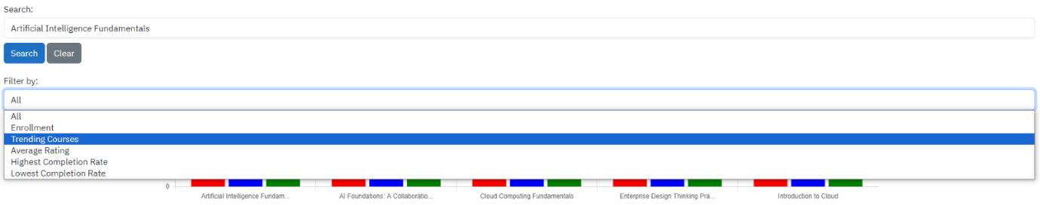

1. After selecting a specific course, extra information will be displayed on that course.

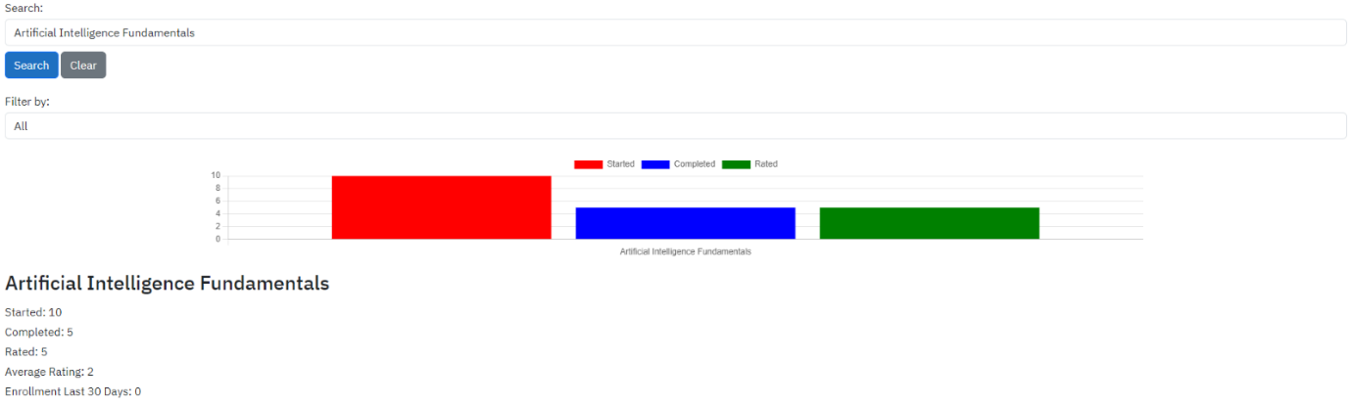

By Ben